

To: City Executive Board

Date: 23rd November 2012
Item No:
Report of: Head of Corporate Property

Title of Report: Oxpens Meadow – Dedication as QEII Field

Summary and Recommendations

Purpose of report: To consider the dedication of part of Oxpens Meadow as a Queen Elizabeth II Field, by imposing restrictive covenants in favour of the Field In Trust/National Playing Fields Association, to remain as public open space in perpetuity.

Key decision – No

Executive lead member: Councillor Bob Price and Colin Cook

Report Approved by:
Executive Director, City Regeneration:
Finance:
Legal:
Head of Environmental Development

Policy Framework: Improve the local environment, economy and quality of life policy objective of the Oxford City Council Corporate Plan. West End Area Action Plan.

Recommendation(s): The City Executive Board is recommended to:

1. Agree to the dedication of part of Oxpens Meadow (as specified on the attached plan) as a QEII Field as a lasting legacy to Her Majesty Queen Elizabeth II in her Diamond Jubilee year.

2. Agree to amend the resolution of CEB 8/2/12 and instead to agree for the Council to enter into a Deed of Dedication with Fields In Trust (FIT) for the area highlighted on the attached plan, as detailed herein and otherwise on terms and conditions to be agreed by the Head of Corporate Property.

Introduction

- The Council has extensive land holdings in the Oxpens Road area of the city which includes the Ice Rink and adjacent sites. The area known as Oxpens Meadow lies immediately adjacent to the east of the Ice Rink and has boundaries to the east and south with Castle Mill Stream and the River Thames respectively.

- Access onto the site is via an unmade footpath leading from the Oxpens Road entrance across the Meadow towards the river, whilst the site can be accessed from two points to the south of the site via a made up footpath which runs parallel to the river.

- The meadow comprises of publicly accessible green open space which is primarily used for sports, pastimes, or informal recreational or reflective space. It is popular with local residents and tourists given the extensive river views, and has in the past been used as a area for organised public events such as fun fairs or the circus etc.

- Notwithstanding the medium to long term development and regeneration potential of the Oxpens area, the Council have in the past expressed their desire to protect the Meadow as public open space in perpetuity.

- Accordingly at Council on 25th January 2010 the following Motion was adopted by general assent.

“Council invites the City Executive Board to apply to the County Council to register the area shown in green on the Identified Sites Map at page 5 of Part 1 of the adopted West End Area Action Plan as a Town Green under the Commons Act 2006 as the best means of securing the long term protection of the Meadow from encroachment.”

- A plan is attached to this report which shows the area concerned.

- The motion follows on from the application submitted by SENDRA (St. Ebbes New Development Residents’ Association) that Oxpens Meadow, comprising 5 acres (2,2ha), be designated a Town Green under s.15 of the commons Act 2006. This application is with the County Council, as the relevant authority, for consideration.

- A report was issued to CEB on 8 February 2012, where a resolution was approved to:

  - Apply for Town Green status for Oxpens Meadow after works to the area for compensatory flood storage are completed.

Background

- Oxpens Meadow was acquired by the City Council from Christchurch College in 1923. In all some 16 acres of land was acquired as public open space under section 164 of the Public Health Act 1875. This land included what is now the Ice Rink and adjacent car park, part of the Oxford and Cherwell Valley College site together with Oxpens Meadows.

- The recent West End Area Action Plan of June 2008 confirmed the Oxpens site as a development site and Oxpens Field (WE 8) as an open space to be enhanced. However the policy also explained that flood compensation measures would need to be implemented on this space.

- A flood risk assessment study had indicated that part of the developable part of the Oxpens site was within the flood risk area. However, through providing a comparable volume of flood storage elsewhere this would enable the flood risk to be overcome. The proposal in the West End AAP was that this would be achieved through removing the higher tipped material on the Oxpens Meadow, adjacent to the Ice Rink, re-profiling and restoring the Meadow as open space.

QEII Field – Deed of Dedication

- As an alternative to Town Green registration officers consider that an initiative by Fields In Trust (FIT), part of the National Playing Fields Association (NPFA), could be an effective way of protecting Oxpens Meadow in this way. The initiative aims to commemorate the Queen Elizabeth II diamond jubilee year by dedicating sites as open spaces to be protected in perpetuity. This is achieved by the landowner entering into a Deed of Dedication for the benefit of FIT/NPFA, which will preserve the status of the Meadow as public open space.

- The QEII Fields Challenge aims to safeguard hundreds of outdoor recreational spaces in perpetuity for future generations in celebration of the Diamond Jubilee and as a permanent tribute to Queen Elizabeth II.

- Officers believe that this site would qualify for the FIT scheme, and the dedication in this way would form a lasting legacy to Her Majesty within central Oxford. The timing of this dedication within 2012 could mark a turning point for the Oxpens area, as the West End Regeneration Area Action Plan is brought forward in the coming years.

- It is thought that this initiative will afford the Meadow the protection that has been sought by stakeholders that have also initiated the application to register the site as a Town Green. The Council is advised that it has a robust case against a Town Green designation on this land, if it chose to exercise this. It is proposed that the Deed of Dedication will be agreed between SENDRA and the FIT/NPFA, in return for an undertaking from SENDRA to withdraw/not pursue the application for Town Green status. SENDRA have been engaged on the proposals and made initial comments on the draft Deed of Dedication.

- The Deed of Dedication that will be executed between the Council and FIT/NPFA will be drafted in such a way to permit flood mitigation as required, in accordance with the master planning and likely future development of the Oxpens area.

- The ownership of the site will remain with the Council and will continue to be maintained by the City Council’s Parks and Leisure team. The existing uses of the park will be protected, including the possibility of public events etc.

- For the avoidance of doubt the area behind the Ice Rink will not be included as part of the Dedication of the Meadow.

- This initiative is proposed as an alternative to the land being transferred by the City Council to a form of Community Trust, however it will not preclude this possibility in the future. The FIT initiative will allow the immediate protection of the Meadow, without the need to form and constitute a trust to take on the liability of the Meadow and demonstrate a viable and sustainable business plan for the medium and long term operation of it. All such opportunities could continue to be explored in the medium to long term if required.

- In order to reserve the Council’s ability to pursue this opportunity, officers have initiated an application for the site to be considered as a possible QEIII field. The formal adoption as a QEII field will be subject to approval by CEB and the agreement and execution of the Deed of Dedication, and registration of the deed with the Land Registry.

- The dedication of the site in this way will mean that the site will acquire the QEII status, however there is no requirement for an actual name change where sites are instantly recognisable with their current name. This will operate in the same way that King George V Fields often do, which members may be familiar with.

Level of Risk

- A risk assessment has been undertaken and the risk register is attached (Appendix 2). The main potential risk for the City Council is that someone or a body other than SENDRA seeks to start the process afresh of making a Town Green application.

Climate Change/Environmental Impact

- The continued use of Oxpens Meadows as open space would protect an important urban green spaces.

Equalities Impact

- Oxpens Meadow is already accessible to all. This proposal would maintain this.

Financial Implications

- The assumption is that the only costs to the Council are the legal and registration costs of the Deed of Dedication. The Council will not be responsible for any costs incurred by FIT/NPFA.

Legal Implications

- This registration of the Deed of Dedication on the Meadow will restrict the land to the use outlined in the Deed.

- All day to day decisions will continue to be the responsibility of the Council. However NPFA would need to approve any change of uses, alterations, building works, construction, leases, wayleaves, transfers and sales etc.

- Nothing in these proposals is intended to prejudice the Council’s ability to oppose a town green application on the land should this be appropriate, and the Council would do so, particularly in the event that any such application were made before the flood remediation work had been completed.

Conclusion

- Officers believe that the FIT scheme is ideally suited to this site, and the scheme provides an effective and immediate measure to protect and preserve the status of Oxpens Meadow as an area of public open space. This will alleviate the need for a Town Green application by either the Council or stakeholder groups, whilst retaining rights to implement flood attenuation measures as part of the wider Oxpens regeneration plans in the future.

Name and contact details of author:-
Name - Richard Hawkes
Job title – Corporate Asset Manager
Service Area / Department – Corporate Property
Tel: 01865 252124 e-mail: rhawkes@oxford.gov.uk

List of background papers:
Version number: 3
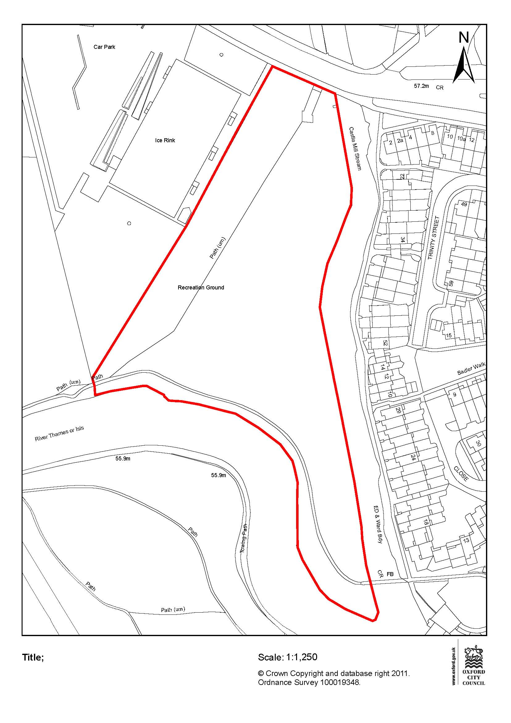

Appendix 2

Risk Register

Risk Score Impact Score: 1 =Insignificant; 2 = Minor; 3 = Moderate; 4 = Major; 5 = Catastrophic Probability Score: 1 = Rare; 2 = Unlikely; 3 = Possible; 4 = Likely; 5 = Almost Certain

No. | Risk Description  Link to Corporate Obj | Gross Risk |  | Cause of Risk | Mitigation | Net Risk |  | Further Management of Risk:  Transfer/Accept/Reduce/Avoid |  | Monitoring Effectiveness |  |  |  | Current Risk
 |  | I | P |  | Mitigating Control:  Level of Effectiveness:  (HML) | I | P | Action:  Action Owner:  Mitigating Control:  Control Owner: | Outcome required:  Milestone Date: | Q  1  ☹😐☺ | Q  2☹😐☺ | Q  3☹😐☺ | Q4☹😐☺ | I | P
1 | Someone else submits a fresh Town Green bid | 4 | 2 | SENDRA agree to withdraw application but a n other starts the process again.  The County Council need to formally agree with the approach. | Mitigating Control:  Good communication with the community of the offer and progress with SENDRA  Level of Effectiveness:  M | 4 | 1 | Action: Close dialogue with SENDRA and the County Council.  Appropriate joint communication to the wider community ( meetings, press, newsletters)  Action Owner: Head of Corporate Property  Mitigating Control:  Control Owner: | Outcome required:  Milestone Date:  1st: within one month of CEB.
3 | SENDRA do not agree to the withdraw Town Green application | 4 | 2 | Any offer from the City Council would require an undertaking from SENDRA. These have to be negotiated yet. | Mitigating Control:  Give time and care to dialogue with SENDRA  Level of Effectiveness:  M | 4 | 1 | Action: Accept  Action Owner:  Mitigating Control:  Control Owner: | Outcome required:  Milestone Date:

